1. Test of working cells
This test is used to determine the number of working cells in the studied crossbar array of memristive devices. It is recommended to be performed at the initial stages of getting acquainted with the studied crossbar array of memristive devices. For its execution, an experimental plan has been created (file “writable.json” which is contained in the tickets folder) in the MemriBoard program, consisting of three tickets with the following parameters (Figures 1.1 – 1.3).

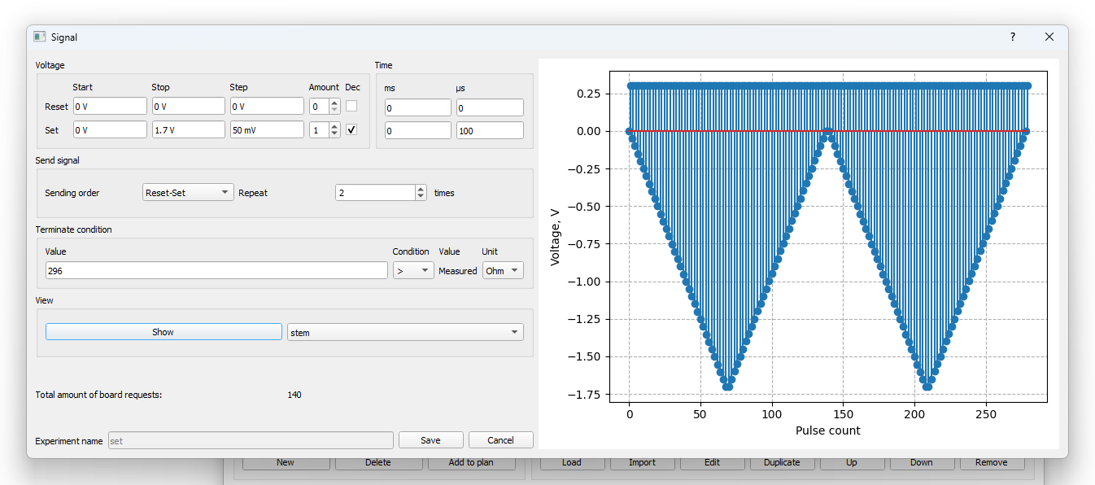
Figure 1.1 – SET procedure with stop condition upon reaching memristor resistance of 296 Ohms or less.

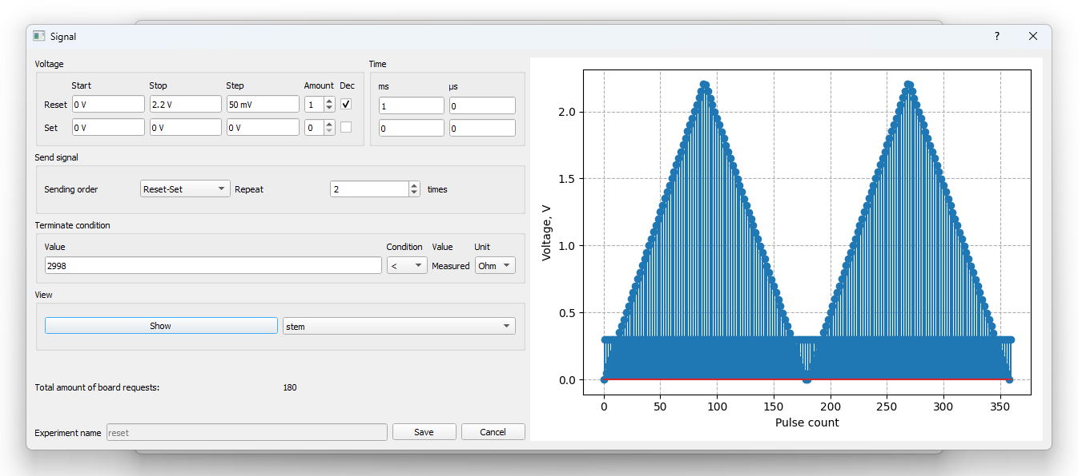
Figure 1.2 – RESET procedure with stop condition upon reaching memristor resistance of 2998 Ohms or more.
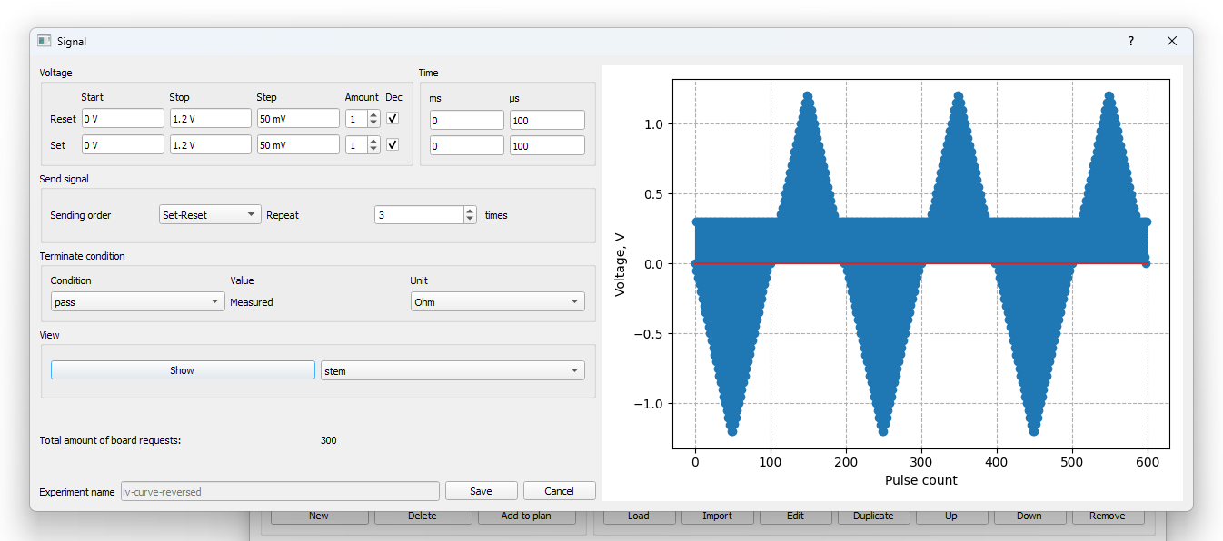
Figure 1.3 – Measurement of current-voltage characteristic 3 times.

Next, a condition is applied to the cells – if the minimum resistance is greater than 100 Ohms and the ratio of maximum resistance to minimum resistance is greater than 2, then the cell is considered working.

To perform it, the following sequence of actions must be carried out:
1. Perform it first for any single cell of the crossbar.
2. After that, open the “Testing” window.
3. Select or create a folder for this experiment (it is advisable to use an empty folder).
4. Select the “writable” experiment for all cells of the crossbar.
5. After successful execution, go to the “Result analysis” tab in the same “Testing” window and click “Calculate”.
6. As a result, the percentage of working cells will be displayed.

2. Writing with tuning
For writing resistances, a special experiment is used, which consists of 32 tickets. The first ticket performs the resistance writing procedure with stopping upon hitting the specified range (Figure 2.1). The second ticket performs ten readings at a voltage of 0.3 V (Figure 2.2).
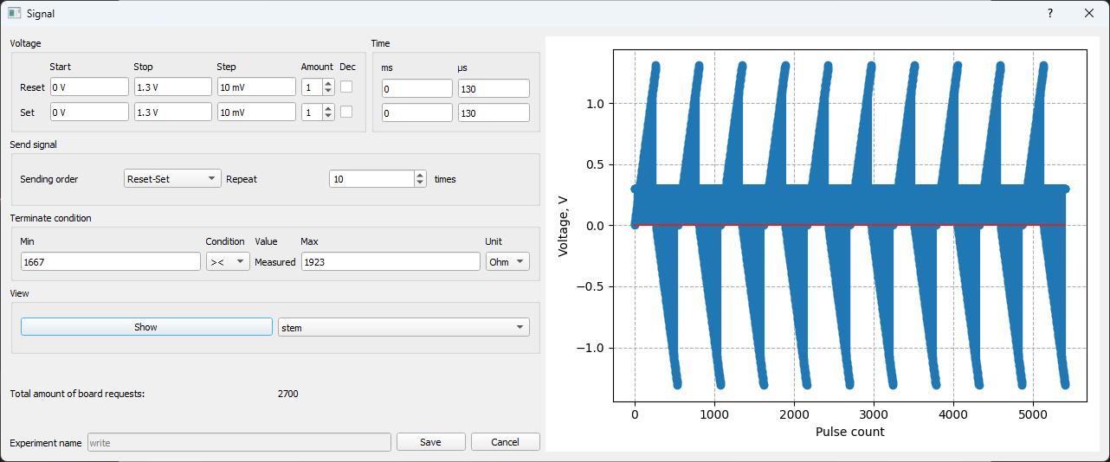
Figure 2.1 – Procedure for writing the range 1667 – 1923 Ohms. For other ranges, the parameters are identical.

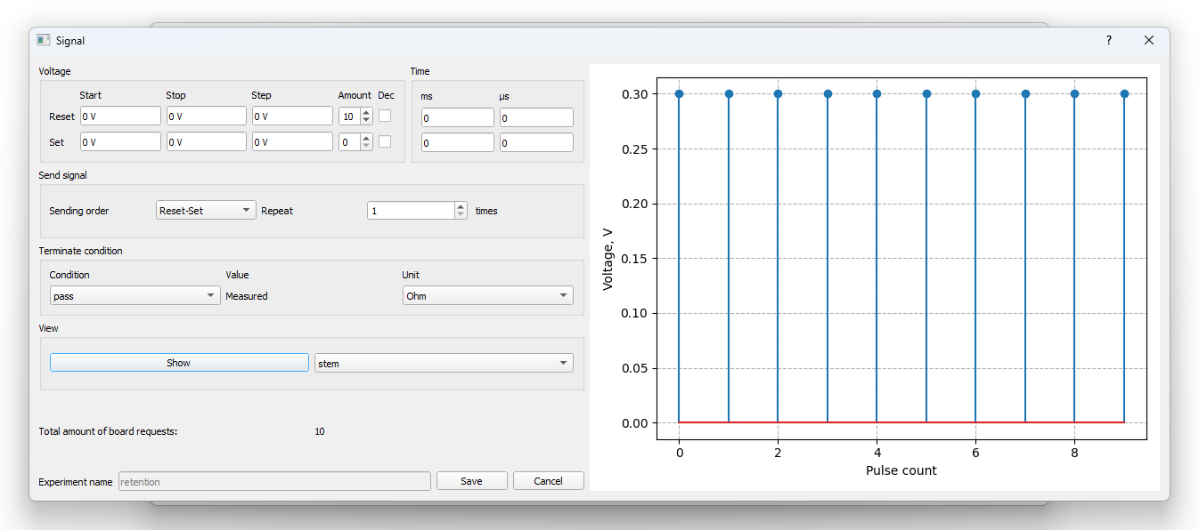
Figure 2.2 – Ten readings at a voltage of 0.3 V.

The remaining 30 tickets consist of a tenfold repetition of automatic resistance tuning to the middle of the range. This is performed by three tickets, two of which are shown in Figures 2.3, 2.4, and the third in Figure 2.2.
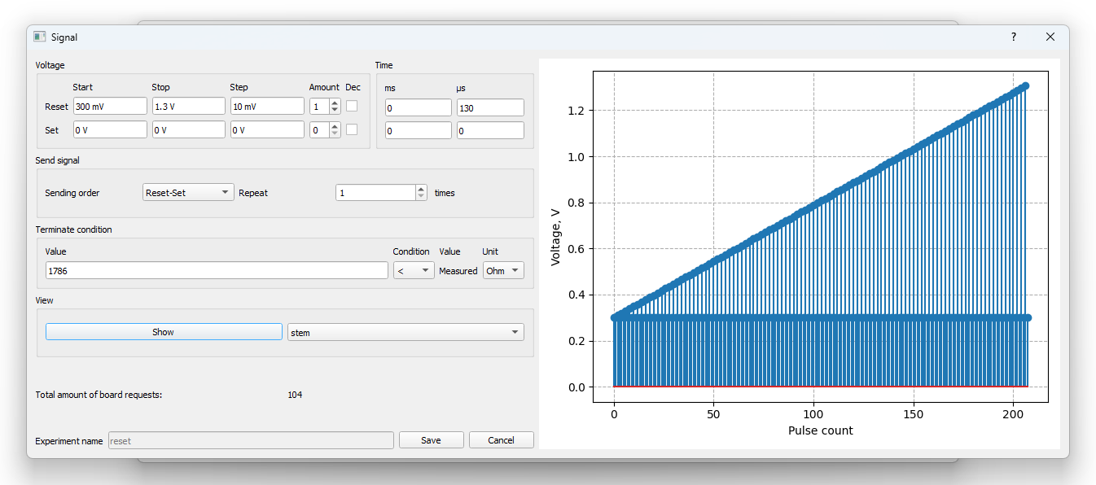
Figure 2.3 – Attempt to perform RESET. It is interrupted upon reaching a resistance greater than the middle of the range.

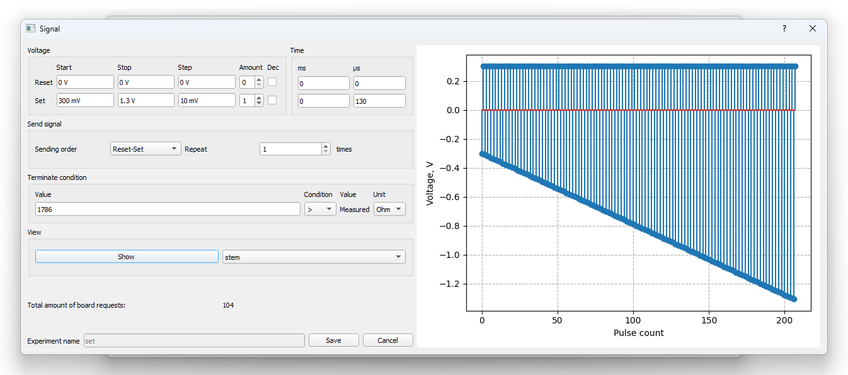
Figure 2.4 – Attempt to perform SET. It is interrupted upon reaching a resistance less than the middle of the range.

An illustration of the operation of such an experimental plan is shown in Figure 2.5.

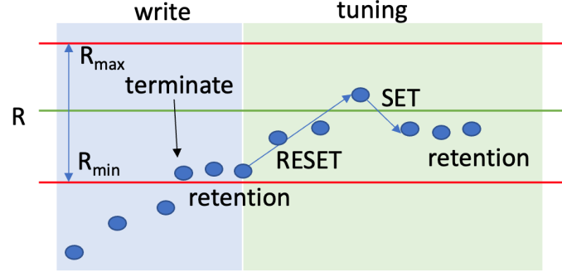
Figure 2.5 – Procedure for writing a resistance level.

To create such experiments for writing the desired resistance in a specific range, there is a special script ‘gen_write.py’ in the program folder. In it, you need to fill in 2 lists, namely “min_res” (list of minimum resistances for the writing and tuning experiment) and “max_res” (list of maximum resistances for the writing and tuning experiment). After running this script, you will have files “min_res”_“max_res”_tuning_10.json created, which can then be used in the MemriBoard program.

